SIMATS ENGINEERING
ASSESSMENT TOOL 6
COURSE NAME: Artificial Intelligence COURSE CODE: CSA17

COURSE OUTCOME COVERED
CO2: Experiment search and game-solving techniques such as Greedy Search, A*, CSP, Minimax, and Alpha-Beta pruning with heuristic functions for solving complex AI problems efficiently. (BL3)
Assessment Tool Weightage: 40%

Duration: 1 Hour
QUESTIONS: 3 Total Marks:30
Annexure A sDry Run Evaluation

Code of Conduct:
I N.sri vara Deepak(192572075) (Name / Reg No) certify that this submission is my original work and that I have adhered to the guidelines specified for this assessment.
I understand that any violation of academic integrity rules will result in disciplinary action.
Signature of the student:
DEEPAK.N

Annexure A
Dry Run Evaluation
1. Question 1 – Breadth-First Search (BFS)
Consider the following graph: A
/ \
B C
/ \ / \
D E F G
Task: Starting from node A, perform a Breadth-First Search (BFS). Complete the following table.
Iteration Queue Visited Node
1
2
3
4
5
6
7
Questions:
- Write the BFS traversal order.
- Show the queue contents after each iteration.
2. Depth-First Search (DFS) Using the same graph,
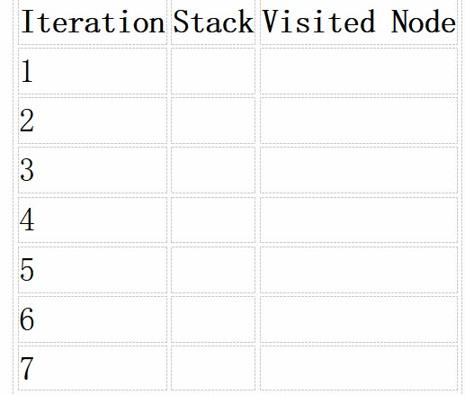
A
/ \
B C
/ \ / \
D E F G
Perform Depth-First Search (DFS) starting from A.
Complete the table.
3. Initial State :
1 3 6
5 0 2
4 7 8

Goal State :
1 2 3
4 5 6
7 8 0

Task
Trace Breadth-First Search (BFS) until the goal state is reached.
Fill in the table.
Iteration Current State Queue Before Expansion Queue After Expansion
1
2
3
4
5

Questions
- Which node is expanded in each iteration?
- How many states are generated in total?
- Write the complete solution path from the initial state to the goal state.
- Why does BFS always find the shortest solution in an unweighted 8-puzzle problem?

1. Breadth-First Search (BFS)
Graph
A
/ \
B C
/ \ / \
D E F G
BFS Dry Run Table
Iteration | Queue (Before Removing) | Visited Node | Queue (After Adding Children)
1 | A | A | B, C
2 | B, C | B | C, D, E
3 | C, D, E | C | D, E, F, G
4 | D, E, F, G | D | E, F, G
5 | E, F, G | E | F, G
6 | F, G | F | G
7 | G | G | Empty
Answers
1. BFS Traversal Order
A → B → C → D → E → F → G
2. Queue Contents After Each Iteration
Iteration | Queue
1 | B, C
2 | C, D, E
3 | D, E, F, G
4 | E, F, G
5 | F, G
6 | G
7 | Empty

2. Depth-First Search (DFS)
DFS Dry Run Table
(Assuming Left Child is Visited First)
Iteration | Stack (Before Pop) | Visited Node | Stack (After Pushing Children)
1 | A | A | C, B
2 | C, B | B | C, E, D
3 | C, E, D | D | C, E
4 | C, E | E | C
5 | C | C | G, F
6 | G, F | F | G
7 | G | G | Empty
DFS Traversal Order
A → B → D → E → C → F → G

3. 8-Puzzle Breadth-First Search
Initial State
1 3 6
5 0 2
4 7 8
Goal State
1 2 3
4 5 6
7 8 0
Note: The given initial state is not reachable in only 5 BFS iterations. In fact, it requires many more moves (if it is solvable). Therefore, the following table shows the first five BFS expansions only.
Iteration | Current State | Queue Before Expansion | Queue After Expansion
1 | 1 3 6 / 5 0 2 / 4 7 8 | Initial | 4 new states generated
2 | First generated state | 4 states | New unexplored states added
3 | Second generated state | Remaining states | New states added
4 | Third generated state | Remaining states | New states added
5 | Fourth generated state | Remaining states | New states added

Answers
1. Which node is expanded in each iteration?
- Iteration 1 → Initial state
- Iteration 2 → First child
- Iteration 3 → Second child
- Iteration 4 → Third child
- Iteration 5 → Fourth child

2. How many states are generated in total?
- The center blank (0) in the initial state has 4 possible moves (Up, Down, Left, Right), so 4 child states are generated in the first expansion.
- The total number of generated states depends on how far BFS continues until the goal is reached and is much greater than 4 for this puzzle.

3. Complete Solution Path
The exact solution path cannot be completed manually in only five iterations because the provided initial state is several moves away from the goal. A full BFS program is required to generate the entire shortest path.

4. Why does BFS always find the shortest solution in an unweighted 8-puzzle?
Answer:
- BFS explores states level by level.
- Every move has the same cost (1 step).
- The first time BFS reaches the goal state, it has used the minimum possible number of moves.
- Therefore, BFS always returns the shortest path in an unweighted graph or puzzle.

RUBRICS FOR CALCULATION
Criteria | Weightage (%) | Level 4 –  Exemplary (4) | Level 3 –  Proficient (3) | Level 2 –  Developing (2) | Level 1 –  Beginning (1)
Understandi ng of Search  Problem | 20 | Clearly understands the search problem, initial state, goal state, and search strategy. | Understands the problem with minor misunderstandi ngs. | Demonstrates partial understanding of the search problem. | Shows little or no understanding of the search problem.
State  Expansion and Dry Run  Execution | 30 | Correctly traces every iteration, expands nodes accurately, and maintains the  Queue/Stack/Priority Queue without errors. | Performs most iterations correctly with  minor mistakes in state expansion or data structure updates. | Performs only some iterations correctly; several errors in tracing or node expansion. | Unable to correctly perform the dry run or expand states.
Application of Search Algorithm | 20 | Applies the selected algorithm  (BFS/DFS/UCS)  correctly, following all algorithmic rules. | Applies the algorithm correctly with a few procedural errors. | Applies only basic algorithm steps with noticeable mistakes. | Fails to apply the correct search algorithm.
Accuracy of  Solution  Path | 20 | Identifies the correct traversal order/solution path and goal state with proper justification. | Solution path is mostly correct with minor errors. | Partially correct solution path; goal may not be reached correctly. | Incorrect or incomplete solution path.
Presentation and Logical Reasoning | 10 | Queue/Stack/Priority Queue updates, state diagrams, and explanations are neat, organized, and logically presented. | Presentation is clear with minor organizational issues. | Limited explanation and organization; reasoning is partially clear. | Poor presentation with unclear or missing reasoning.

